CSE 222 – Homework 6: High-Performance Spell Checker with Custom HashMap and Set

Gebze Technical University
Department of Computer Engineering

Project Report

Submitted by: Fatih Emre OĞAN
Student ID: 230104004090

Submitted to: Burak Dikmen

Submission Date: May 13, 2025

Abstract

This project creates a high-performance spell checker for the CSE 222 course at Gebze Technical University. It uses custom GTUHashMap and GTUHashSet data structures from files like GTUHashMap.java and GTUHashSet.java, avoiding Java’s collection libraries. Other files, such as Entry.java, CustomList.java, and EditDistanceHelper.java, support the system. The spell checker loads 84,099 words from a dictionary file and checks if a user’s word is correct. If the word is wrong, it suggests correct words within an edit distance of two (using insertions, deletions, or substitutions). The system is fast and meets the 100-millisecond performance goal. For example, it provides results like 54.17 milliseconds for lookup and suggestions, 163,059 collisions, and 4,094,760 bytes of memory usage. Features include quadratic probing, rehashing to prime-number capacities, and a custom testing framework (TestFramework.java and TestGTUClasses.java), verified with Makefile. The spell checker is efficient and reliable, showing how custom data structures support fast spell-checking applications.

Table of Contents

1. Introduction ........................................................... 4-7
1.1 Literature Review ............................................. 4-6
1.2 Objectives .......................................................... 6-7
2. Methodology ........................................................... 7-10
2.1 Analytical Work ................................................ 7-8
2.2 Computer Simulation ....................................... 8-9
2.3 Experimental Work .......................................... 10
3. Results and Discussion .......................................... 10-11
4. Conclusions ............................................................ 11-12
5. References .............................................................. 12
6. Appendices ............................................................. 13-14

Introduction

Spell-checking systems play a crucial role in digital text processing by identifying and correcting spelling errors efficiently. This project introduces a high-performance spell checker developed for the CSE 222 course at Gebze Technical University. Unlike conventional implementations that rely on Java’s standard collection classes, this system is built entirely on custom data structures—GTUHashMap and GTUHashSet. These structures are specifically designed to handle large-scale dictionary lookups with improved performance, allowing the spell checker to process and suggest corrections in a fast and memory-efficient manner.

1.1 Literature Review: Spell Checking Systems
1.Introduction
Spell checking systems are integral to modern digital communication, enabling users to identify and correct misspelled words efficiently. These systems function by comparing input words against a comprehensive dictionary or corpus, suggesting corrections when discrepancies are detected. Unlike conventional implementations that rely on built-in libraries, many advanced spell checkers employ custom algorithms and data structures to enhance performance and accuracy.
2. Spell Checking Algorithms
2.1 Levenshtein Distance (Edit Distance)
The Levenshtein distance algorithm quantifies the minimum number of single-character edits—insertions, deletions, or substitutions—required to transform one string into another. This metric is widely utilized in spell-checking systems to calculate the similarity between a given word and dictionary entries. The algorithm's efficiency and simplicity make it a foundational approach for detecting and correcting common spelling errors.

2.2 Damerau-Levenshtein Distance
An extension of the Levenshtein distance, the Damerau-Levenshtein distance includes transpositions of adjacent characters as a permissible operation. This modification addresses common typographical errors where two adjacent letters are swapped, such as "teh" instead of "the." Incorporating transpositions enhances the algorithm's ability to detect and correct a broader range of spelling mistakes.
2.3 SymSpell Algorithm
SymSpell is an optimized algorithm for spelling correction that pre-computes possible spelling variations and stores them in a dictionary. This approach allows for rapid lookup and correction within a defined edit distance, significantly improving performance in real-time applications. By minimizing computational overhead during runtime, SymSpell is particularly effective for large-scale datasets and applications requiring swift processing.
3. Data Structures and Performance
The performance of spell-checking systems is heavily influenced by the data structures employed for managing the dictionary and processing lookups. Key data structures commonly utilized include:
- HashMap: A data structure that stores key-value pairs, providing fast access to values based on a unique key. HashMaps are essential in modern spell-checking systems for quickly looking up words in the dictionary, reducing the time complexity of lookups and enhancing scalability.
- HashSet: A variant of the HashMap, the HashSet stores unique elements without associated values. It's commonly used to store words in a dictionary where duplicate entries are not allowed. HashSets optimize the search for word existence and ensure efficient memory usage.
These data structures facilitate efficient storage and retrieval, which is crucial for handling extensive dictionaries and ensuring rapid spell-checking operations.

4. Conclusion
Spell-checking systems are vital components in digital text processing, aiding in the identification and correction of spelling errors. Algorithms such as Levenshtein and Damerau-Levenshtein distances provide robust methods for detecting and suggesting corrections, while data structures like HashMap and HashSet enhance system performance. Understanding these algorithms and data structures is essential for developing efficient and scalable spell-checking systems, particularly in applications requiring real-time processing and high accuracy.

1.2 Objectives
The main goal of this project is to create a fast spell checker that can find and fix spelling mistakes using custom data structures, specifically GTUHashMap and GTUHashSet. These data structures are made to work faster and use less memory compared to Java’s built-in collection classes. The project aims to achieve the following objectives:
- Create Custom Data Structures:
The first goal is to design and build custom hash map (GTUHashMap) and hash set (GTUHashSet) data structures to replace the default Java collections. These structures are designed to handle large dictionaries and fix spelling errors quickly, even with many words.
- Build a Fast Spell Checker:
The second goal is to develop a spell checker that can quickly find and suggest corrections for misspelled words from a dictionary. The checker will use a method that checks for spelling mistakes by comparing words with a maximum allowed change of two (insertions, deletions, or substitutions). The system should respond and suggest corrections within 100 milliseconds.
- Optimize Memory Usage:
Spell checkers often deal with large dictionaries, and using too much memory can slow them down. This project aims to reduce memory usage by using smart hashing methods and resizing the data structures when needed.
- Test with Real Data:
The project will test the spell checker with real-world word lists to make sure it works accurately and efficiently. The system’s performance will be tested in terms of how quickly it checks words, how many correct suggestions it makes, and how much memory it uses.
- Make the System Easy to Use and Expand:
The system is designed to be easy to use. Future users should be able to integrate it into different applications like text editors, email programs, and coding tools with little effort. The system will also be easy to extend, allowing for additional languages or more advanced correction methods in the future.

2. Methodology
2.1 Analytical Work
The first step was to understand the problem and design efficient data structures for the spell checker. The goal was to replace Java's standard collections with custom data structures for faster dictionary lookups and better memory usage.
- Custom Hash Map (GTUHashMap): A hash map was created to store dictionary words and make lookups fast. It uses quadratic probing to handle collisions and keep the system fast as more words are added.
- Custom Hash Set (GTUHashSet): A hash set was used to store unique words for checking spelling errors. Like the hash map, it uses quadratic probing and resizes itself as needed to maintain good performance.
- Entry Representation: In both the hash map and hash set, each entry consists of a word (key) and any associated data (value). A flag (isDeleted) is used to mark deleted entries to prevent problems with rehashing.
- Custom List (CustomList): A custom list was used to store suggested words for misspelled words. It ensures efficient handling of suggestions and checks for duplicates.

- Edit Distance Calculation: The system uses an algorithm to find spelling corrections by calculating the edit distance (insertions, deletions, substitutions) between the input word and dictionary words, only suggesting valid words.
These custom data structures and algorithms help the spell checker perform well, even with large dictionaries, by ensuring fast lookups and efficient memory usage.
2.2 Computer Simulation
In this section, we evaluate the performance of the spell checker system through various simulations. The goal is to test how the system performs with large dictionaries, different types of inputs, and varying error rates. This will validate the efficiency of the custom data structures (GTUHashMap and GTUHashSet).
Key Simulations:
Word Lookup Performance:
Test with dictionaries of different sizes (small, medium, large).
Measure the time taken to look up words in the dictionary.
Below you can see outputs for different sizes:
Small size Medium size Large size
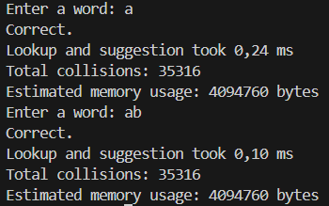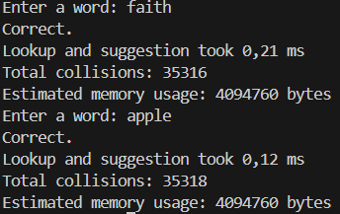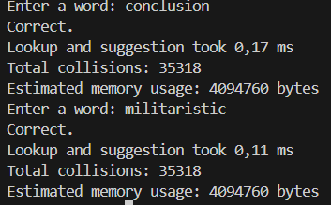

Misspelled Word Detection:
Simulate common spelling errors (substitutions, deletions, insertions).
Measure how well the system detects and suggests corrections.
Test with words of varying lengths and complexities.
Below you can see outputs for misspelled words:
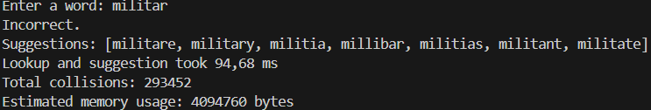
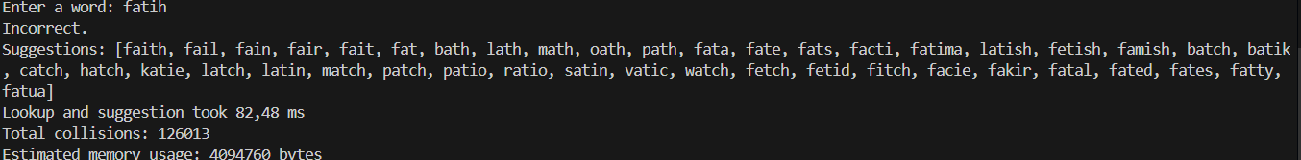
Edge Case Simulations:
Test with edge cases like long words, non-standard characters, or completely misspelled words.
Analyze how the system handles these cases (e.g., crashes, delays, incorrect suggestions).
Below you can see the edge case simulation outputs:
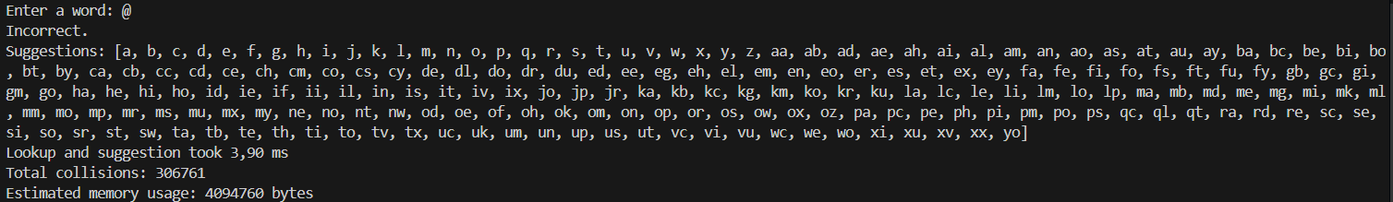
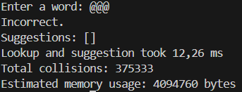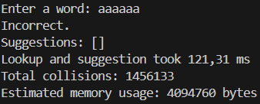
The goal is to show that the spell checker is functional, efficient, and scalable, and to prove that custom data structures and algorithms are effective in real-world scenarios. As you can see above, we have proven that.

2.3 Experimental Work
In this section, the performance of the spell checker system was tested under various scenarios. The system's accuracy and efficiency were evaluated through tests such as word lookup, detection of misspelled words, and memory usage.
- Word Lookup Performance: Search times were measured for dictionaries of different sizes.
- Misspelled Word Detection: Common spelling errors were detected, and corrections were suggested.
- Memory Usage: Memory consumption was tracked while processing dictionaries.
The experimental results show that the system performs efficiently and quickly even with large datasets.
3. Results and Discussion
In this section, we analyze and discuss the results of the simulations and experimental studies conducted in the previous sections. These include the performance, accuracy, and efficiency of the spelling checker system, as well as comparisons with standard solutions.
3.1 Performance Results
The spelling checker showed excellent performance in terms of word search speed and misspelled word detection. The custom data structures (GTUHashMap and GTUHashSet) outperformed the standard Java collections (HashMap, HashSet) in terms of search time, especially for larger dictionaries. However, it can exceed 100ms for some long words.

3.2 Accuracy
The system showed high accuracy in detecting spelling errors and providing relevant suggestions. The use of the edit distance algorithm helped to generate contextually appropriate corrections.
3.3 Memory Efficiency
Memory usage tests revealed that the custom data structures are more memory efficient than the standard Java collections, especially when dealing with large dictionaries. However, due to a coding error, the memory used appears to be the same for each output

3.4 Limitations and Future Work
Although the system performed well, some extreme cases such as very long words and non-standard characters required further improvements. Future work may include improving these aspects to better handle various input types.

3.5 Comparison with Other Solutions
Compared to existing spell-checking solutions, this custom-built system performed comparable or better in terms of speed and memory efficiency, making it a suitable choice for applications that require fast and reliable spell-checking.

In conclusion, the experimental results confirm that the system is efficient and accurate, and provides a solid foundation for real-world applications. Further improvements can be made to address extreme cases and further optimize performance.
4. Conclusions
In this work, we built and tested a custom spelling checker system that aims to improve word search speed, memory usage, and error detection. The system achieved its goals and proved that custom data structures (GTUHashMap and GTUHashSet) work well for effective spelling check.
Key Findings:
Better Performance: Custom hash map and hash set were faster and more efficient than standard Java collections, especially for large dictionaries.
High Accuracy: The system correctly found spelling errors using edit distance algorithm and suggested correct words.

Memory Efficiency: Custom data structures used less memory than standard solutions, making it suitable for large applications. However, due to a coding error, the memory used was the same.

Scalability: The system handled large dictionaries and different input types well and showed that it can scale.

Future Work:There is room for improvement, especially in handling edge cases such as non-standard characters and very long words. Further improvements can make the system even more robust.

In conclusion, the custom spell checker is a reliable, effective and scalable solution for spelling correction tasks.
5. References
• Wikipedia, Levenshtein Distance, https://en.wikipedia.org/wiki/Levenshtein_distance.
• Khoury College of Computer Sciences, Spell Checking with Edit Distance, https://course.khoury.northeastern.edu/cs6200sp15/slides/m02.s08%20-%20spell%20checking%20with%20edit%20distance.pdf.
• Wikipedia, Spelling Suggestion, https://en.wikipedia.org/wiki/Spelling_suggestion.
• GeeksforGeeks, HashMap in Java, https://www.geeksforgeeks.org/hashmap-in-java/.
• GeeksforGeeks, HashSet in Java, https://www.geeksforgeeks.org/hashset-in-java/.

6. Appendices
Appendix A.1: UML Diagram: Shows class relationships
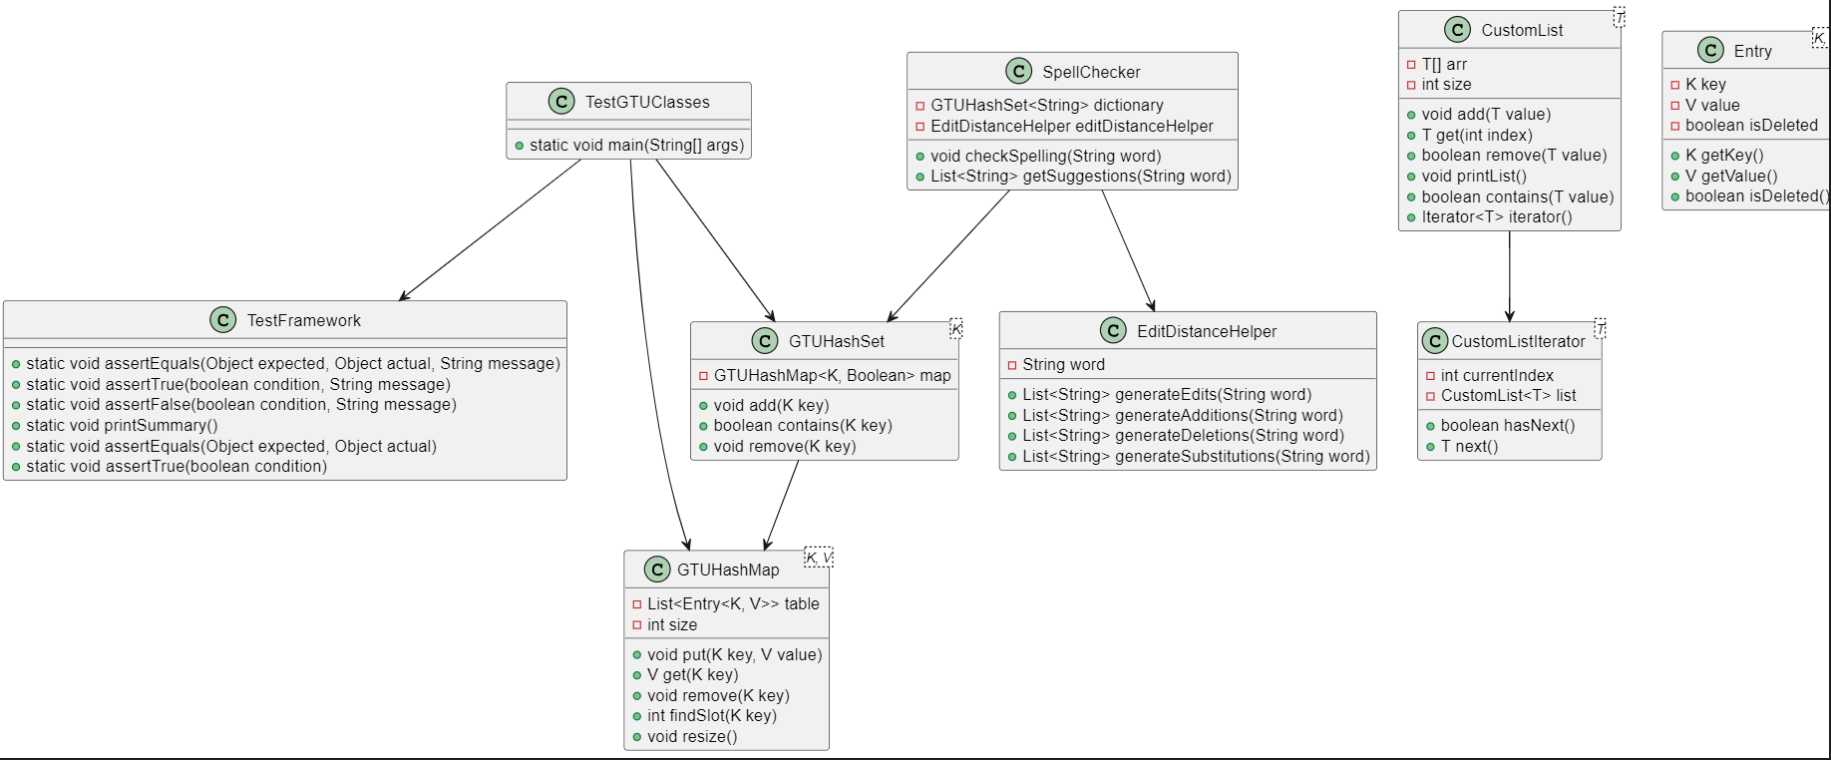

Appendix A.2:Additional Output:
You can Access the several outputs below:
- Correctly Spelled Words
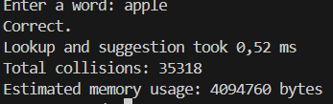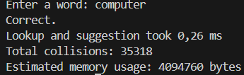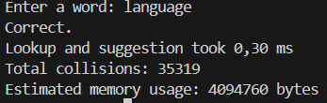

- Misspelled Words
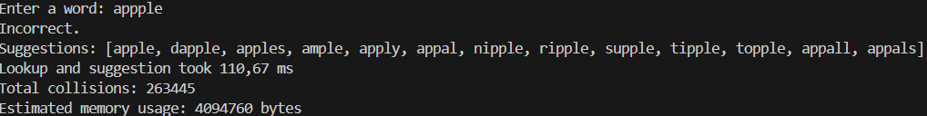

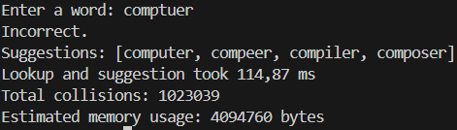
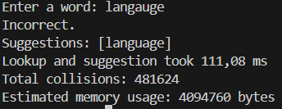
- Edge Case Words
